Serial To Wireless Lan 802.11b/g : E-P132-W
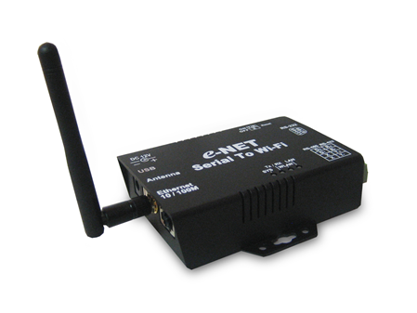

WLAN
- Standard Compliance: IEEE 802.11 b/g
- Spread Spectrum Technology: DSSS, OFDM
- Tx Power 11b: Maximum 20 dBm
- Tx Power 11g: Maximum 18 dBm
- Rx Sensitivity: -70 dBm @ 54 Mbps, -85 dBm @ 11Mbps
- Transmission Rate: 54 Mbps (max.) with auto fallback (54,48, 36, 24, 18, 12, 11, 9, 6, 5.5, 2, 1 Mbps)
- Transmission distance: Up to 100 meters(@12 Mbps, in open areas)
- Security: WEP 64-bit/128-bit data encryption, AES, WPA2
- Antenna Connector: Reverse SMA
- Network Mode: Infrastructure, Ad-Hoc
LAN for configuration / Ethernet hub
- Ethernet: 10/100 Mbps, RJ45
- Protection: Built-in 1.5 KV magnetic isolation
Serial
- No. of ports: 1 RS-232/422/485 port, male DB9, S/W selectable
- RS-232 Signals: TxD, RxD, RTS, CTS, DTR, DSR, DCD, GND
- RS-422 Signal : Tx+ , Tx- , Rx+ , Rx – ( Surge Protect )
- RS-485 Signal : Data+ , Data- ( Surge Protect )
- Serial Line Protection: 15 KV ESD for all signals
Serial Communication Parameters
- Parity: None, Even, Odd, Space, Mark
- Data bits: 5, 6, 7, 8
- Stop bits: 1, 1.5, 2
- Flow control: RTS/CTS, XON/XOFF
- Speed: 110 bps to 460.8+ Kbps
Power Requirements
- Power input 1: 12 VDC
Environmental
- Operating Temperature: -10 to 70°C (32 to 131°F), 5 to 95% RH
Storage Temperature:-20 to 85°C (-4 to 185°F), 5 to 95%RH
Regulatory Approvals
- RoHS
- EMC: FCC Class A, CE Class A
Software Features
- Protocols: ICMP, IP, TCP, UDP, DHCP, BootP, ARP / RARP, Telnet, RTelnet, DNS, SNMP MIB II, HTTP, SMTP, SNTP
- Serial mode: Virtual Com / TCP Server / TCP Client / UDP / Serial Tunnel with advanced settings of
  - TCP Alive Check Timeout
  - Inactivity Timeout
  - Delimiter for Data Packing
  - Force TX Timeout for Data Packing
- 4 Hosts simultaneous connection: Virtual Com / TCP server / TCP Client (only raw data)
- Security: HTTPS, SSH v2
- Event notification by email / SNMP trap
SNMP Trap
- Cold/Warm Start
- DSR, DCD Changed
- IP Changed
- Authentication Fail
SNMP Response
- System MIB,
- Interface MIB,
- ICMP, IP, TCP MIB
- UDP MIB
- RS-232 MIB
- Utilities: Windows NT/2000/XP/2003/VISTA
  - Device discovery
  - Auto IP report
  - Device setting (run-time change, no rebooting)
  - Access control list
  - Group setting
  - Device monitoring

  - Serial port monitoring
  - Log info
  - Group Firmware update batch
- Virtual COM/TTY Drivers (WDM mode, configuration in windows device manager): Windows NT/2000/XP/2003,VISTA,WIN 7

